NutriDiet (E- Nutritionist & Dietician)
(Project Proposal)


Project Code
BS-112010

Project Advisor
Mr. Ramzan Malik (internal)
Dr. Zonaira Masood (external)
Project Manager
Dr. Muhammad Illyas

Project Team

Sr. No | Name | Roll No | Role
1. | Fatima Masood | BSEF19M020 | Team Lead
2. | Esha Tahir | BSEF19M011 | Team Member
3. | Sehrish Munir | BSEF19M010 | Team Member

Submission Date
11th October 2022
Table of Contents
1. Abstract 3
2. Background and Justification 3
3. Project Methodology 4
4. Project Scope 5
5. High-level Project Plan 5
6. References 5

Abstract
Nutrition is important for living a healthy life. Most people neglect their diet due to which they face many day-to-day problems. To solve nutrition and diet-based issues, we have decided to build software that will suggest a customized diet plan and water intake levels with reminders according to BMI for a normal routine diet. Moreover, it will also deal with specific diet plans based on pregnancy (first trimester, second trimester, and third trimester). It will use several defined rules based on age groups, gender, height range, and weight range and calculate the number of calories required according to the rules. It will offer consultation with specialized doctors according to generated diet plans and other online and face-to-face issues and will include diet counseling via articles and videos.

Background and Justification
The background and justification for NutriDiet are as follows:

Background
Health is very important to keep going through life. We should also take proper care of our health but due to our busy and tough routine, we sometimes neglect our health. From time to time as technology is increasing, we can get our diet plan and reminders regarding that right at our home. Work done on generating diet plans went only to the state where we have to book appointments with doctors through their webpage then the doctor will first analyze the state and then make a customized diet plan. Some examples of apps are:
- Lifesum (Lifesum, n.d.)(1): The user adjusts the water level and selects dishes himself for generating a diet plan. It does not generate diet plans for people having any medical history. Users need to have proper appointments and consultations with doctors online.
- Fitelo (Fitelo, n.d.)(2): It tracks key health metrics, access meal plans; explore exclusive content, and schedule calls and consultations with online coaches and doctors. It works on disease management (PCOD/PCOS, Thyroid, and Diabetes) and weight management (weight loss).
- JM Nutrition (JM Nutrition, n.d.)(3): It gives detailed counseling but needs consultation with a doctor. A nutritionist will provide facilitation concerning a selected area, and the software will not generate any result with the help of data and calculations.
- MyFitnessPal (myfitnesspal, n.d.)(4): It will give the net calorie goal for gaining, losing, or maintaining weight with no diet plan and suggests water intake levels accordingly.
- EatThisMuch (eatthismuch, n.d.)(5): Eat This Much creates personalized meal plans based on food preferences, budget, and schedule selected by users. It helps to reach diet and nutritional goals with a calorie calculator, weekly meal plans, and grocery lists.
- Noom (NOOM, n.d.)(6): Noom is for BMI values above 18.5, following World Health Organization (WHO). Noom works with a combination of psychology, technology, and human coaching.
- Nutrilio (nutrilio, n.d)(7): Nutrilio focuses on healthy lifestyles and making diet choices. It keeps track of Food intake and water level. It works on choices made by users.
- Virtual nutrition consultation(8): This was the survey done right after the pandemic of covid-19. There were many suggestions that telemedicine holds a promising potential for nutritional consultation during a pandemic outbreak period. They told that data is needed for establishing adequate standards of nutritional care and practice, using telemedicine in crisis as well as in routine periods. They investigated the extent, quality, and challenges of dietetic counseling during the pandemic.
- Telenutrition(9): In this article, Telenutrition can enable RDNs (Reverse Domain Name Service) to maintain normal workloads and provide patients with uninterrupted access to nutritional health care. As at that time it was too soon to know the long-term impacts of the COVID-19 pandemic on the Italian healthcare delivery system, their results provide a picture of how telehealth can enhance nutrition care. It was important at that time that RDNs utilizing telehealth resources possess the capacity to provide high-quality, efficient, and secure services using evidence-based guidance.
- Ethical and technical aspects of Nutrition teleconsultation(10): This Brazilian food association article presents the main aspects of Nutrition teleconsultation in Brazil and across the world. Some advantages of Nutrition teleconsultation i.e. cost reduction, improved access to services, increased adherence, reduced geographic barriers, increased involvement of patients and their families, and improved self-care are focused; limitations included lack of access to the necessary infrastructure, feeling uncomfortable with the technology, concerns about safety or desire to be assisted in person, among others.

Justification

We are planning to develop software that will do the same work as nutritionists do and the software will generate the diet plan. In this, the user will fill out a questionnaire and the software will conclude the results by analyzing the data and performing different calculations to generate diet plans according to rules defined for the need of major food components i.e. carbohydrates, lipids, and proteins.

Project Methodology
We will go with a deep learning process and our software, NutriDiet, will work in the following ways:

- User will open the main home page of a website from where he can select avail of services, contact us, and read about us.
- NutriDiet will generate different diet plans by the information collected from different questionnaires according to specific services. In addition, it will suggest an amount of water intake level of the body accordingly with reminders.
- If a user selects a diet plan according to BMI with the help of age, weight, gender, and height, it will calculate BMI and compare it with the standard according to which it displays whether the user is fit, overweight, or underweight. Then according to the requirements of food components (carbohydrates, proteins, lipids, and vitamins) for a body, it will calculate the required number of calories and generates diet plans consisting of four meals (breakfast, lunch, brunch, and dinner).
- If a user selects a diet plan for pregnancy, it will generate diet plans according to the need for food components in different trimesters of four meals (breakfast, lunch, brunch, and dinner) according to the required number of calories.
- Users can read diet-related articles and watch videos for awareness of the importance of diet and nutrition.
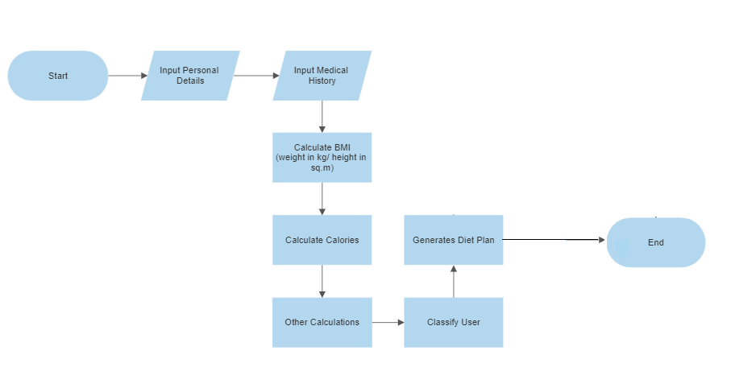

Figure 1: Workflow diagram

Project Scope
Different plans are generated for different BMI results (fit, overweight, underweight), and periods of pregnancy (first trimester, second trimester, and third trimester). It will also generate customized diet plans for diabetic, arthritic, and heart patients.

High-level Project Plan
The estimated high-level project plan is in Figure 2.
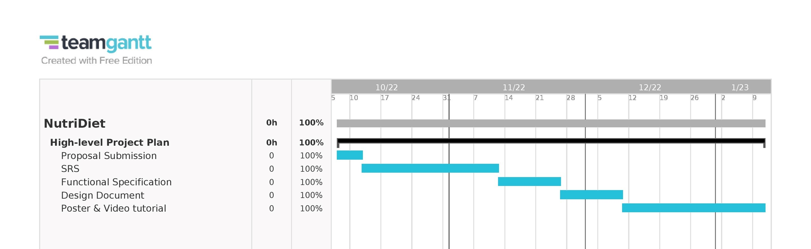
Figure 2: Gantt chart of work scheduled

References

- Lifesum. (n.d.). Retrieved from Lifesum: https://lifesum.com/
- Fitelo. (n.d.). Retrieved from Fitelo: https://fitelo.co/
- JM Nutrition. (n.d.). Retrieved from JM Nutrition: https://www.julienutrition.com/
- myfitnesspal. (n.d.). Retrieved from myfitnesspal: https://www.myfitnesspal.com/
- eatthismuch. (n.d.). Retrieved from eatthismuch: https://www.eatthismuch.com/
- NOOM. (n.d.). Retrieved from NOOM: https://www.noom.com/
- Nutrilio. (n.d.). Retrieved from Nutrilio: https://nutrilio.net/
- BRICARELLO, L. P., & POLTRONIERI, F. (2021). Aspectos éticos e técnicos da teleconsulta de Nutrição em tempos da COVID-19. Revista de Nutrição, 34, e200265.
- Gnagnarella, P.; Ferro, Y.; Monge, T.; Troiano, E.; Montalcini, T.; Pujia, A.; Mazza, E. Telenutrition: Changes in Professional Practice and in the Nutritional Assessments of Italian Dietitian Nutritionists in the COVID-19 Era. Nutrients 2022, 14, 1359. https://doi.org/10.3390/nu14071359
- Kaufman-Shriqui, V., Sherf-Dagan, S., Boaz, M., & Birk, R. (2021). Virtual nutrition consultation: What can we learn from the COVID-19 pandemic? Public Health Nutrition, 24(5), 1166-1173. doi:10.1017/S1368980021000148

